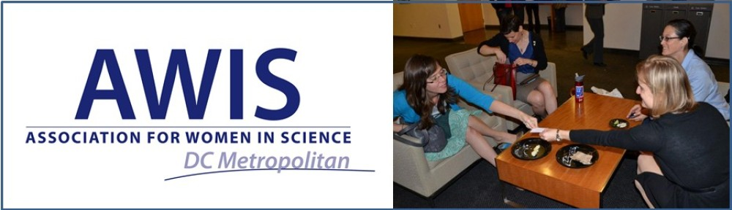
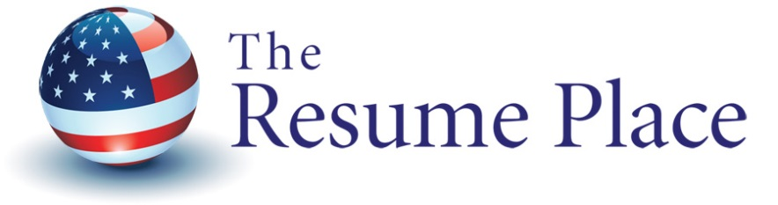

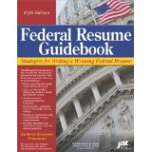

FEDERAL RESUME WRITING WORKSHOP
FOR SCIENTISTS, PH.D.s , and Post-Docs
Emily K. Troutman, MPP, Instructor
Sept. 18th, 6 to 7:30 pm ET
Location: AAAS Building, 1200 New York Ave
Registration: $5 members / $20 non-members
Course Description:
In 90 minutes, you will gain insight into how to write a competitive science federal resume and how to match your resume toward a USAJOBS vacancy announcement.
What you will learn:
- How to write a competitive federal resume
- How to answer the self-assessment questionnaires
- How to analyze keywords and specialized experience for your federal resume
- How to present and organize your education, dissertation, research projects, research assistant positions in the federal resume.
- How to write about your knowledge, skills, abilities and competencies in the federal resume.

TESTIMONIAL:
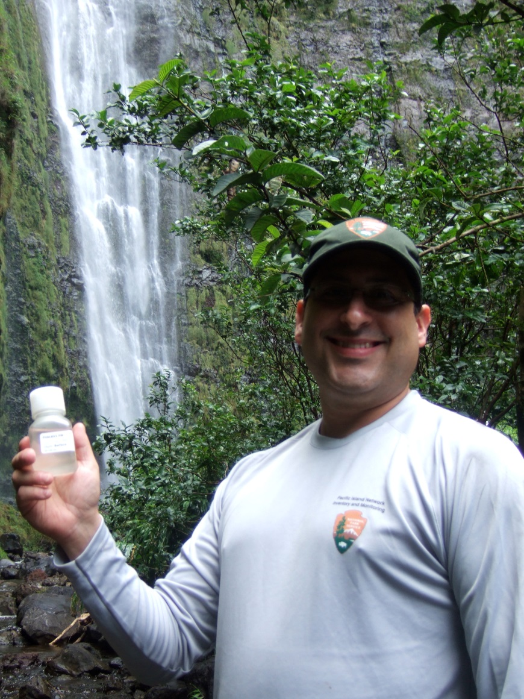
I landed my dream job, and I have Kathryn Troutman and The Resume Place to thank for it. As an Ecologist for the National Park Service, I now live in Hawaii, work in amazing National Parks, and support a mission to steward America’s natural resources. But more importantly, this job represents stability for me and my family. That’s why I’m so thankful for Kathryn Troutman’s help. She revamped the resume that got me this job using the system published in her books. Her approach was so successful, the resume that landed the interview for this job got me another interview at the same time. Such successes are why I routinely refer other job-seekers to her books, company, and advice.
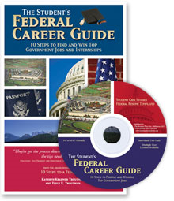
Emily Troutman, MPP, CFRWC, CFJST
Emily K. Troutman is a freelance executive writer and editor, specializing in helping federal managers enter the elite Senior Executive Service (SES). Emily is the co-author of The Student's Federal Career Guide: 10 Steps to Find & Win Top Government Jobs & Internships. In 2005, their book was awarded the Benjamin Franklin Award for the Best Career Guide. Over the years, Kathryn and Emily have collaborated on many books and projects. Emily was developmental editor for the Military to Federal Career Guide, as well as the Job Seeker’s Guide: Ten Steps to a Federal Job, 2nd Edition
Emily received a Master's Degree in Public Policy from the University of Minnesota, Hubert H. Humphrey Institute of Public Affairs, where she concentrated her studies on National Security and Foreign Policy. She speaks Turkish and Arabic. Emily approaches her work with Federal managers as both a journalist and a consultant; she seeks compelling stories of accomplishments and complements those stories with in-depth, technical knowledge of the Federal government.
Emily was just awarded the designation as Citizen Ambassador from the United Nations for her winning video production answering the UN question: What would you tell World leaders? She will represent the UN for two years in social media commentary. She has been on ABC, CNN, quoted in Baltimore Sun, Catonsville Times and other mass media. Her video has been viewed 4,000 times.
United Nations Press Release: http://www.un.org/apps/news/story.asp?NewsID=32591&Cr=akasaka&Cr1
Emily is an experienced trainer and co-trainer in Federal Resume and KSA Writing topics in various federal agencies including: Washington Headquarters Center, BRAC Center in Crystal City, U. S. Navy Fleet and Family Support Center Transition Counselors, NASA Leadership Development Program, National Forest Service, Defense Logistics Agency and numerous other agencies.

